Elsey Beck
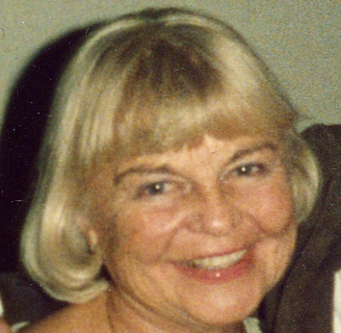
Elsey _. _. was born in Detroit to Nicholas _. from Belarus and Caroline _. from Ukrainia. Growing up in Detroit, she attended the Detroit Public Schools. Around the time that Elsey entered Wayne State University, her family moved to a wonderful house on California Street in Highland Park. At Wayne State, she attained a Masters Degree in Education, was a member of the Alpha Sigma Tau sorority, and met her future husband, Forrest E. Beck, Jr.

After graduation, Elsey began teaching high school in Detroit. She and her sister, Aulga, the _. sisters, as they were known, taught at Miller High School during its glory years of the mid and late 1940's. In 1947, Elsey and Forrest were married. A few years later they began a family and Elsey retired from teaching in 1950. Forrest was employed by Detroit Oil Company, his father’s business, and eventually assumed ownership of the company.

Elsey was active in the Democratic Party, and thus moved naturally into her second career as the manager of the Michigan office of the Fourteenth Congressional District, for Congressman Lucien N. Nedzi. During her years in that office, she managed some of Congressman Nedzi's reelection campaigns. More recently, Elsey enjoyed the opportunity to make many friends as she worked in sales at the Treasure Trunk resale shop, first in Royal Oak, and then in Birmingham.

Throughout her life, Elsey was involved in sports. While at Northeastern High School she played on the tennis team and was captain of the basketball team. She was a charter member of the Beverly Hills Racquet Club, attended tennis camps, and enjoyed playing in tennis and golf leagues into her eighties. Elsey loved to travel, visiting Canada, Europe, and Mexico. She made many trips to watch tennis exhibitions. Her memberships included the Women's City Club, the Detroit Boat Club, and the Founder's Junior Council. It was a treat to hear Elsey play the piano. She was a self-taught musician and she liked to play ethnic folk songs.

Elsey chose to remain in her Detroit home on West Hildale, a lovely street near Palmer Park. Whenever she found blight in the area, she would wage a personal campaign to persuade the property owner to clean it up. Elsey remained physically active to her last day, working in her yard and going on numerous day-trips with various groups, especially the Ferndale Seniors. Now and then, Elsey would watch her grandsons for the day. Nick and Nate always looked forward to their excursions with “Nanny.”

Last year, Elsey died suddenly on Friday afternoon, October 6, the day before her eighty-fourth birthday. She is survived by her sister, Aulga Prokopowicz, daughter, Alexis Beck, son, Christopher Beck (Theresa Zajac), and grandchildren, Nicholas and Nathaniel Beck.

Elsey enjoyed volunteering at the Art Institute and participated in many of their educational trips. Donations in her name can be made to the Detroit Institute of Arts.

The above biography is what I wrote (with Lex) for mom’s memorial service which took place at the Kulick Center in Ferndale, on Saturday, October 6, 2007, the anniversary of her death. (I omitted some last names in this copy for security purposes. If you would like me to fill in the blanks, just send me an e-mail.)

One additional story: In February 1998, mom went to the hospital to have her knee x-rayed. They told her, “You need a pacemaker” and admitted her on the spot. She didn’t even know anything had been wrong. In less than a week they had to do the operation again. Mom had broken the internal wires while carrying a bag of lawn fertilizer. After that she conceded: “I guess I’d better listen to the doctor this time.” Mom didn’t know the meaning of the word, “sedentary.” She was always doing something; always outside; talking to every child, teenager and adult that walked down Hildale. I am certain that the West Hildale neighborhood misses Elsey almost as much as we do.

